Website

Headline and Subheading

As is

Headline: Power your Certification Process with Confidence
Subheading: A comprehensive platform that connects
Issuers and Verifiers, enabling secure, seamless,
and efficient management of certifications with
Ease.

Suggested

Headline: Transform Credentialing: Secure, Instant, and Smart with CertCheck
Subheading: Revolutionize Academic Verification and Issuance using Immutable Blockchain Technology, Starting Today with No Upfront Cost.

Login and demo button

As is

Login button on the landing page leads you to certcheck login but no sign up options. Book your demo button in the first page lacking.

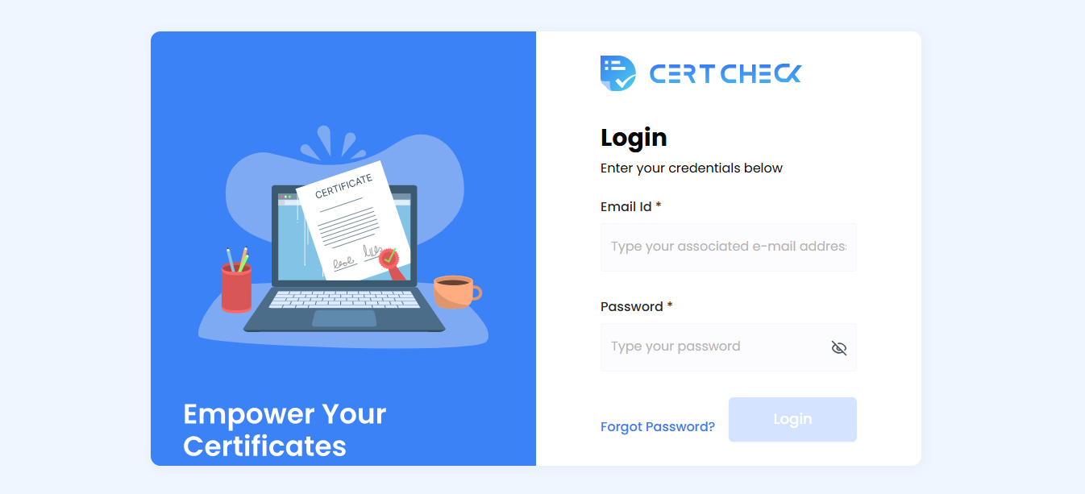

Suggested: As a first time user no options to register/ sign up hence this should be added. Add “demo” button next to login

About Us information

As is
About us tab info and who we are are the same.

Suggested

About Vara can be under About Us tab only. Also add about the awards we have received for blockchain.

Problem statement/ what are we solving missing

As is
Lack of what we solve

Suggested

Briefly state the traditional pain points:
- Time-consuming manual verification (7-14 days).
- Vulnerability to fraud and human errors.
- Fragmented record keeping for institutions.

Key benefits/ Value Proposition to user

As is

Key benefits to the users not mentioned in detail

Suggested

Add USP and key benefits to the users in the landing page like:

- Instant, Real-Time Verification: Emphasize speed (minutes vs. days).
- Blockchain-Secured Authenticity: Explain how immutability eliminates fraud.
- Zero Onboarding Cost for Institutions: Highlight this major financial advantage.
- Comprehensive Issuance & Verification Platform: Cover both sides of the solution.
- Decentralized System (for Verifiers): Explain independent verification without university intervention.
- Customizable Workflow & ERP Integration: Detail adaptability for universities.
- Global Access & Recognition: Address international usability.

How does the platform work

As is

How the platforms works info lacking

Suggested (optional)

Simple flow chart to show the system works

- Common Questions asked

As is

Common Questions asked can be FAQ

Also some questions on data privacy can be answered like the data will be stored on universities systems because they are genuinely the questions that universities ask us.

